C3A: Python Scripting

The script automates subdomain reconnaissance using Subfinder and Httpx, notifications are sent to a telegram bot. When the script runs the basic information about the scan using CLI argument parsing. Then the script checks if httpx and subfinder are in the environment. It will then perform subdomain enumeration where the run command is used. The run command() is executed and saves all the subdomains in the first file. It then checks for live hosts using the output from Subfinder as input for Httpx. The same run command is executed and only live subdomains are saved into the second file.
A conditional statement is used to check if there are any live subdomains printed in the file. If there are, a telegram notification is seen. If none are found, it sends a message no live subdomains were found. The script was tested by first ensuring subdomain enumeration was happening then probing of live hosts. The telegram notification was implemented last.
A problem faced was mainly on downloading httpx. There was confusion between httpx-toolkit and httpx. A problem also occurred when using the Telegram bot API, the right chat ID was not being used. The first chat_id(update_id) was the first one being used.

Output: -
The two files with the subdomains
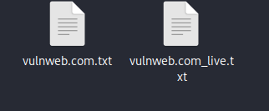

The contents within vulnweb.com.txt
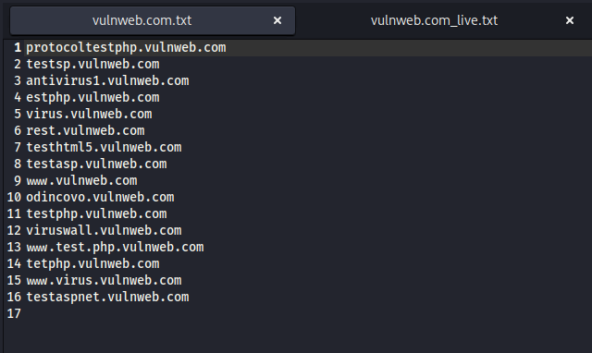
The contents within vulnweb.com_live.txt
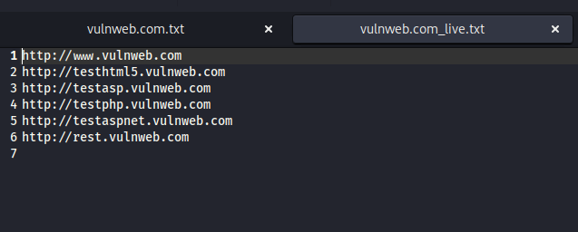

Telegram notification
